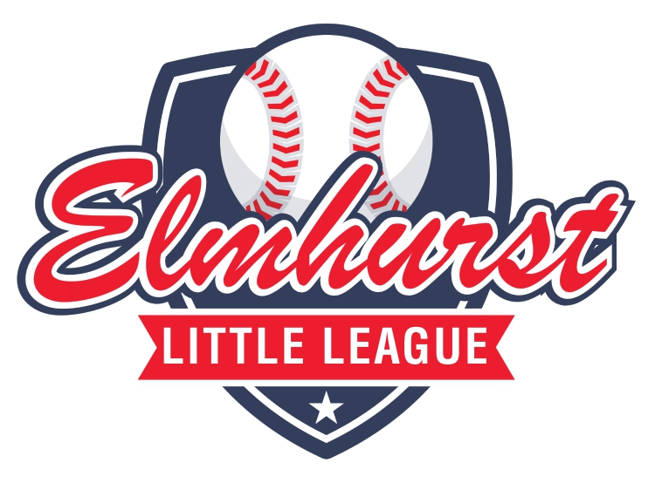
2024 SPONSOR FORM
Elmhurst Little League appreciates your support! By choosing to financially support the park, you are investing into OUR community. As we work to physically help restore the park to its former glory, we are excited to be all in for our community, our players, and the families we get to serve. We hope you’ll join us on our mission!
Although the season has begun, we still need your support to maintain the park and have the funds to do everything needed throughout the season. Below you will find areas we are needing sponsored to keep the park and league running for practices and games.
Please fill out the form and return as soon as possible.
Thank you for supporting Elmhurst Little League!

SPONSORSHIP | AMOUNT | QTY | SPONSORSHIP | AMOUNT | QTY
Outfield Banner | $375.00 |  | Concession Maintenance | $500.00
Umpire Pay | $500.00 |  | Property Renovation | $500.00
General Maintenance | $500.00 |  | Donation in Kind | $
 |  | TOTAL | $
Sponsorship checks can be made payable to:
Elmhurst Little League
PO Box 9673
Fort Wayne, IN 46899

COMPANY NAME: | ___________________________ | PHONE: | ________________________
CONTACT NAME: | ___________________________ | EMAIL: | ________________________
Elmhurst Little League is dedicated to supporting the development of life skills and personal character in our youth through the enjoyment and love of baseball.
CHARACTER • RESPECT • TEAMWORK • ENCOURAGEMENT

